**Weekly Exercises**

**WeeklyExercise_01:**

**Subject:** I have chosen to create a question based on how comfort zone affects learning; compared to the other opinions that we learned in the lesson:

* The effects of interim marks on student performance as described in the Butler 1988 study.
* Conversion of Scratch blocks to UnityScript?
* UnityScript? Programming style

**Question:** An academic study (Butler 1988) looked at the effect different kinds of feedback had on student’s attitude and their final level of achievement. The studies lead to debates of the different factors that affect students including comfort zone (<http://en.wikipedia.org/wiki/Comfort_zone>). It was theorised that if a student didn’t have an appropriate level of comfort, they would be less encouraged to learn and instead procrastinate or such.

Through these debates, another study was made to look at the effect the comfort zone has on their learning by getting a small class of 5 students to take a maths test and after the lesson asking if they felt they were in their comfort zone today?

They studied the students with various considerations in mind like their answer (Positive comment, neutral comment and negative comment), test results (Percentage) with the student’s comments, it was to see if their comfort zone really did have some effect on their learning.

The following table summarises the results of what the students answered:

|  |  |  |
| --- | --- | --- |
| **Student?** | **Test Results?** | **Comment?** |
| **01** | **16%** | **Negative** |
| **02** | **96%** | **Negative** |
| **03** | **100%** | **Positive** |
| **04** | **31%** | **Negative** |
| **05** | **65%** | **Negative** |

From looking at the table, does one’s ‘comfort zone affect their learning?

Write your answer and why?

|  |
| --- |
|  |

**Answer:** Yes.

**Explanation:** Because this will affect your mind-set, emotional status and more. If someone does not feel in the mood for something they will be less inclined to take part or be involved. While, verse via if oppositely someone feels happy and positive they will be encouraged to be more involved. Various factors can change this before, during or after the process, but the state of comfort zone remains the same.

**WeeklyExercise_03:**

**Subject:** I have chosen to a layer of movement interpolation script (Same script as week02) to produce a spline; and I have attached a Trail Renderer to show the path.

**Screenshot:**

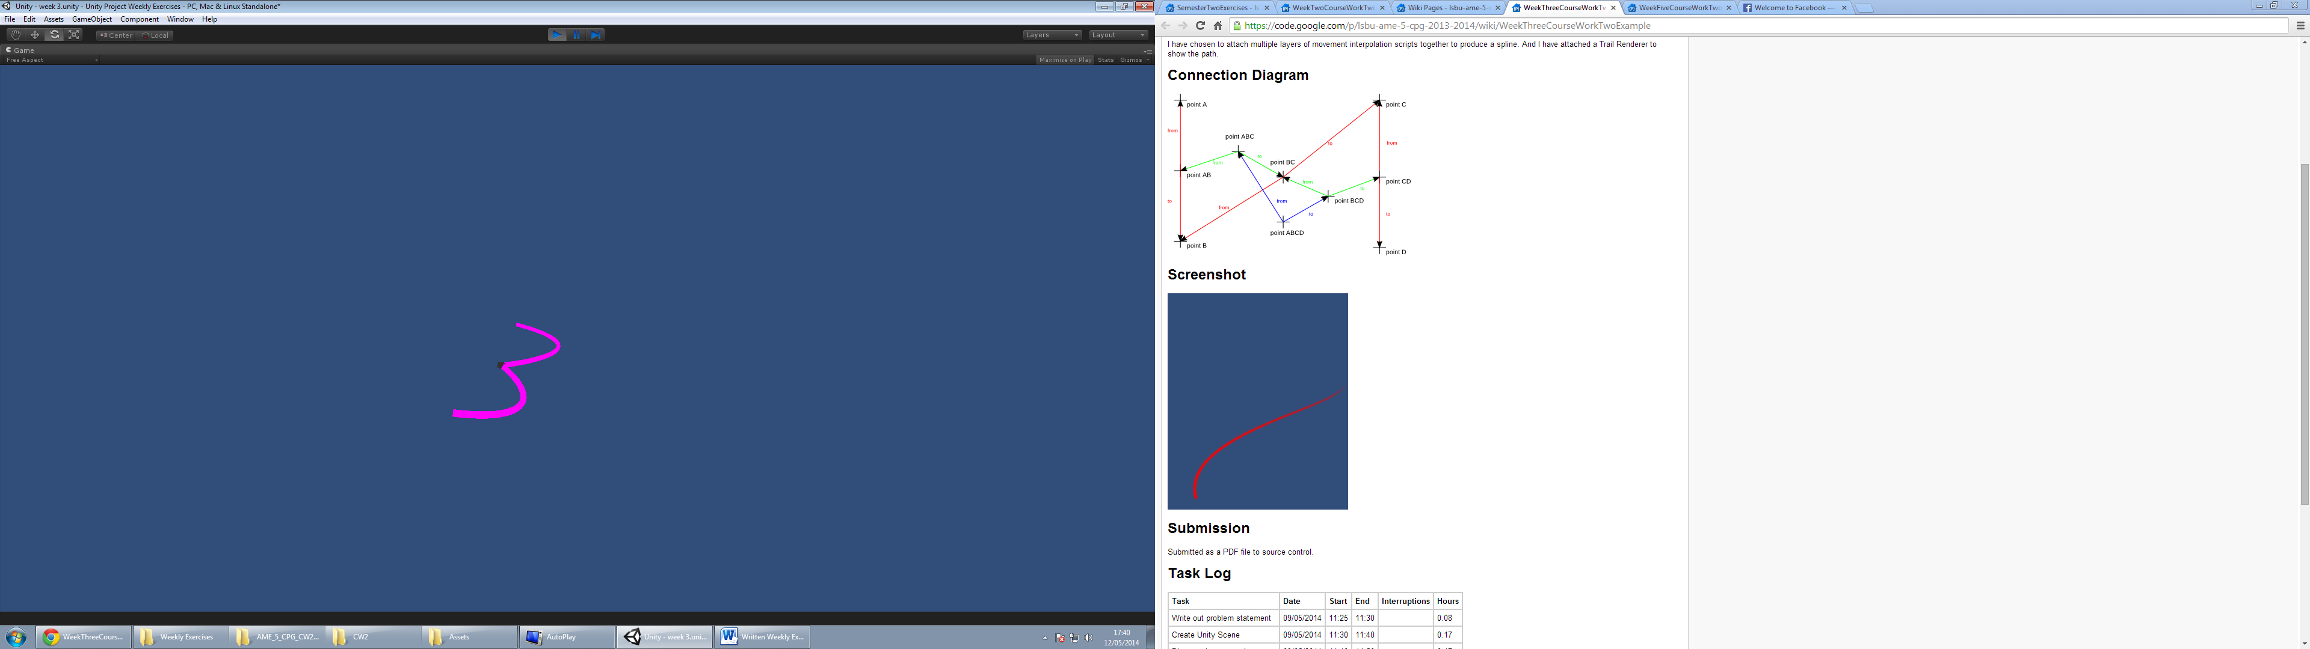

**WeeklyExercise_05:**

**Problem Statement:** To create a two dimensional wave movement in such a way that a gameobject moves along the x and z axis. Once a gameobject reaches the target, get it to travel back with similar wave motion.

The Formula

**Formula:** The formula that I think is appropriate for problem statement above:

**Solution:** Here is the UnityScript for the exercise.

var Speed = 1;

var Amplitude = 1;

var TargetPos : Vector3;

function Update () {

transform.position.y = Mathf.Sin((Mathf.Sqrt((TargetPos.x-transform.position.x)*(TargetPos.x-transform.position.x) + (TargetPos.z-transform.position.z)*(TargetPos.z-transform.position.z)))*Speed) * Amplitude;

}

**Notes:** It does work by making the gameobject go down the x and z axis, yet future experimentation could make it work better. Also, I used <http://galileo.phys.virginia.edu/classes/152.mf1i.spring02/Waves2D_3D.htm> and

<http://answers.unity3d.com/questions/266592/implement-the-equation-as-a-code.html> as reference for this exercise.

**WeeklyExercise_08:**

**Subject:** I have chosen Streets of Rage as my game design to break it down into the technological components needed to make this game. I will diagram my analysis in the form of a technology tree.



Cinematics

Sprite

Button Input

Character Selection

Memory Mapped Hardware Devices

Audio Sample

Co-op Mode

Audio Output

Options Settings

Bitmap

File System

Clock

Player Output

Raster Display

Streets of Rage

Collision Detection

Memory

Physics

CPU

Boolean Logic

Binary Representation

Mathematics (Real Numbers)

Floating Point Number Representation

Integer Representation

The arrows represent the dependencies between the technologies. The dotted lines represent cases where one or another technology is sufficient. For example, above, collision detection could be implemented using sprites or geometry, or both.

**WeeklyExercise_10:**

A table is a structural object that is used to place other objects on top of it for open access storage so that they can be acquired as quick haste. There other function is to act as a task support for life forms to perform actions onto top of them like consuming eatables within a clean perimeter or performing written responsibilities on a flat surface to ensure it is done at a high standard.

These table objects are fairly popular with the local organisms, almost everywhere around the planet coming in hundreds of variables and made with numerous components.

During the process of my scans of this planet Earth for any signs of intelligent sentient beings through technology levels, communication transmissions for languages of the species and energy sources, I discovered this ‘World Wide Web’ to and found these visual display objects (Also, known as images) to show sight examples of these tables I have explained:

